LAB2
Họ tên: Trần Anh Khoa
MSSV: 2211644
Output:
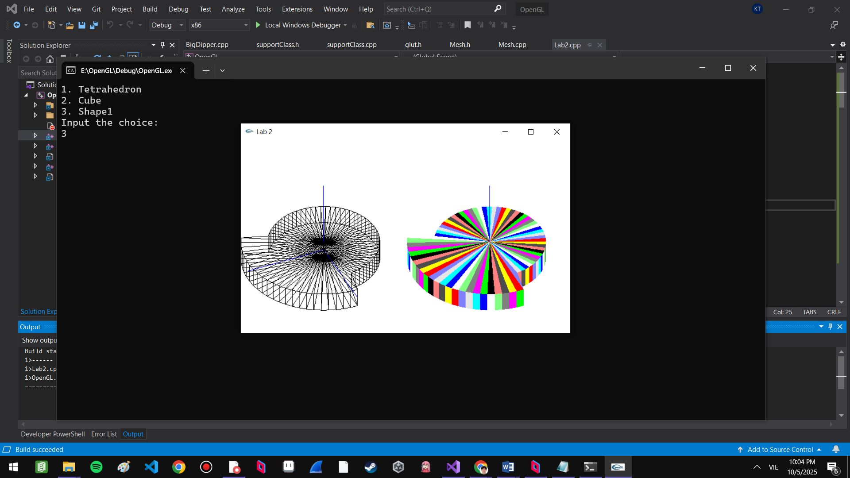
Code:
Mesh.h:
void CreateShape1(int nSegment, float fHeight, float fInnerRadius, float fOuterRadius, float fSectorAngle);

Mesh.cpp:
void Mesh::CreateShape1(int nSegment, float fHeight, float fInnerRadius, float fOuterRadius, float fSectorAngle)
{
numVerts = nSegment * 2 + 2;
pt = new Point3[numVerts];

float halfHeight = fHeight / 2.0f;
float angleStep = 2.0f * PI / nSegment;

// center points
pt[0].set(0, halfHeight, 0);
pt[numVerts - 1].set(0, -halfHeight, 0);

// perimeter vertices
for (int i = 0; i < nSegment; i++)
{
float currentAngle = i * angleStep;
float radius = (currentAngle < fSectorAngle) ? fOuterRadius : fInnerRadius;

float x = radius * cos(currentAngle);
float z = radius * sin(currentAngle);

// Top perimeter vertex
pt[i + 1].set(x, halfHeight, z);

// Bottom
pt[i + 1 + nSegment].set(x, -halfHeight, z);
}

numFaces = nSegment * 3;
face = new Face[numFaces];

int faceIndex = 0;

for (int i = 0; i < nSegment; i++)
{
int current_top_idx = i + 1;
int next_top_idx = (i == nSegment - 1) ? 1 : i + 2;

int current_bot_idx = current_top_idx + nSegment;
int next_bot_idx = next_top_idx + nSegment;

face[faceIndex].nVerts = 3;
face[faceIndex].vert = new VertexID[3];
face[faceIndex].vert[0].vertIndex = 0; // Top center
face[faceIndex].vert[1].vertIndex = next_top_idx;
face[faceIndex].vert[2].vertIndex = current_top_idx;
faceIndex++;

face[faceIndex].nVerts = 4;
face[faceIndex].vert = new VertexID[4];
face[faceIndex].vert[0].vertIndex = current_top_idx;
face[faceIndex].vert[1].vertIndex = next_top_idx;
face[faceIndex].vert[2].vertIndex = next_bot_idx;
face[faceIndex].vert[3].vertIndex = current_bot_idx;
faceIndex++;

face[faceIndex].nVerts = 3;
face[faceIndex].vert = new VertexID[3];
face[faceIndex].vert[0].vertIndex = numVerts - 1; // Bottom center
face[faceIndex].vert[1].vertIndex = current_bot_idx;
face[faceIndex].vert[2].vertIndex = next_bot_idx;
faceIndex++;
}
}

Lab2.cpp:
void myDisplay()
{
...
if (nChoice == 1)
tetrahedron.DrawWireframe();
else if (nChoice == 2)
cube.DrawWireframe();
else if (nChoice == 3)
shape1.DrawWireframe();

glViewport(screenWidth / 2, 0, screenWidth / 2, screenHeight);

drawAxis();
if (nChoice == 1)
tetrahedron.DrawColor();
else if (nChoice == 2)
cube.DrawColor();
else if (nChoice == 3)
shape1.DrawColor();

...
}

void myInit()
{
...
// Draw Shape1
shape1.CreateShape1(70, 1.0f, 2.7f, 4.0f, 120.0f * M_PI/ 180.0f);

}

